Engl 340

IPA Consonant symbols, divided into voiced (v+) and voiceless (v-)
v- | v+ | v- | v+ | v- | v+ | v- | v+
v- | v+ | v- | v+ | v- | v+ | v- | v+
v+ | v+ | v+ | v- | v+ | v+ | v+ | v+
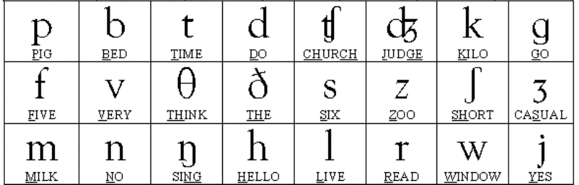

Memorise the symbols of the consonant and whether they are voiced or voiceless.
To hear the sound of these, check this link https://www.youtube.com/watch?v=Ufdm3ufV6pg

Exercise
Transcribe the underlined part of the word. Write v+ next to the voiced consonants and v- next to the unvoiced (or voiceless).
Example:
three /θ/ v-, speech /tʃ/ v-, knows /n/ v+

- pink
- drink
- glow
- George
- shrink
- elephant
- between
- chief
- chef
- knowledge
- this
- thesis
- yesterday
- of course
- push
- pressure
- press
- pleasure
- wealth
- university
- practice
- cream
- kite
- click
- joyful
- joyful
- fudge
- zest
- please
- guess
- ring
- close
- closure
- closure
- laugh

